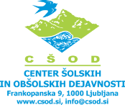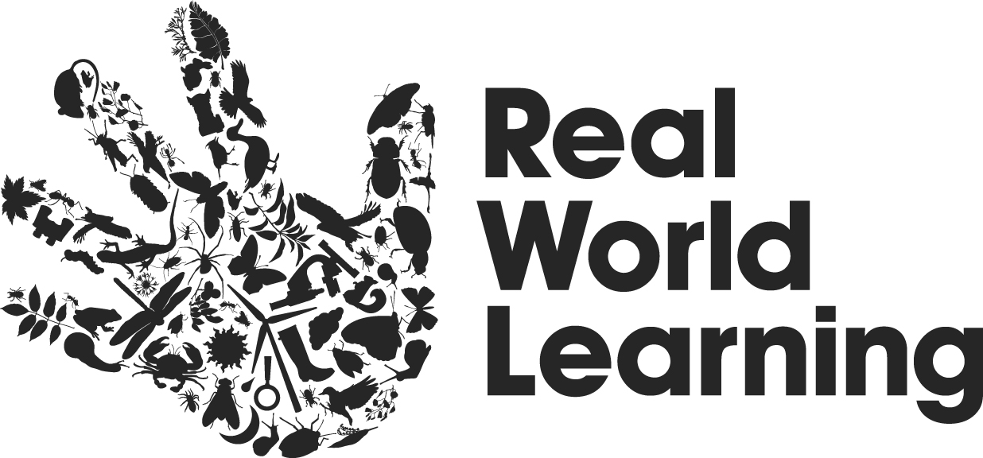

Dissemination event

Report

The First National Conference RWL Network in Slovenia
October 2014

“Hand model”
(“Model roke – izobraževanje za poučevanje v naravi”)

A team of RWLN Slovenia (Ida Kavčič, Irena Brajkovič, Živa Pečavar, Simona Žibert Menart, Nataša Sardinšek, Boštjan Gradišar) and Nina Globovnik (University Maribor) organized and realized a dissemination of Hand model on the 1th national conference for 119 teachers and headmasters.

An interest for attending the conference with the title “Hand model – learning in nature) was very big: so we prepared two conferences in duration of 8 hours each, that took place in CSOE, Centre Planica, Rateče, Slovenia, on two consecutive days, the 16th and 17th of October 2014.

58 teachers from primary and secondary schools of Slovenia attended the first conference and 61 teachers attended the second conference.

Each conference consisted of seven lectures presenting the Hand model, one good practice presentation, and four practical outdoor workshops, among which each of the participants could choose to attend one.

At the end of each conference, the participants evaluated the event through a special questionnaire. We received the answers from 37 participants of the first conference (65 %,) and the answers from 41 participants of the second conference (68%).

Evaluation of the conferences – Centre for School and Outdoor Education

The results are presented in this report.

- Content of the conference

Overall, the participants were more satisfied with the practical part and good practice presentation of the conferences than the theoretical part. This distinction was much stronger with the participants of the second conference, who actually rated the workshops better than the participants of the first conference, while they rated the theoretical part noticeably worse.

The most prevalent suggestion for improvement of the content was that there should be less theory and more practice. As each participant had the option of attending only one of the four workshops, while they wished to attend more than one or even all of them, they suggested for this option to be taken into consideration in further similar events. They also wished for more time for practical examples and less abstract theory in the model presentation.

2. Impact

The participants were relatively happy with the results of the conference. The results show that they believe they got the most new skills in the field of preparing students for sustainable development, and the least in the field of professional competencies teaching. All results are relatively close though, and the main difference is visible between the participants of the first and second conferences, where the participants of the first conference were, on average, more satisfied with the results of the conference than the participants of the second conference.

3. Real World Learning Network

The participants recognized the role of the Real World Learning Network in numerous fields. They agree the most that the role of the network should provide guides based on good practices and outdoor learning instructions, followed by publishing relevant news and informing about seminars in the field of real world learning. The participants saw a slightly lesser, yet still significant role of RWL Network as a consulting entity in the field of real world learning, a lobbying entity for real world learning or a forum for debate in this field. The participants also noted that the RWL Network could perform in other roles within the field of real world learning.

We also asked the participants whether they would be interested in joining the RWL Network and a majority of participants of both conferences replied that they would, with less than a quarter replying that they would not.

Considering the results of the questionnaires, we judge the conferences as successful with some possible improvements.

Ida Kavčič
CoCo RWLN

